**Demo 1**

**Create PivotTable**



**Steps to be followed:**

**Step 1: Open the Excel file**

* 1. Open the file named **Pivot Table.xlsx** and worksheet **Data**

**Step 2: Creating a pivot table**

2.1 Click on **PivotTable** under the Insert tab

2.2 In the Create PivotTable dialog, select the input range and choose a **New Worksheet** for the pivot table

2.3 Click on the Pivot table in the new sheet to get the Fields list. Choose Pivot fields as given below

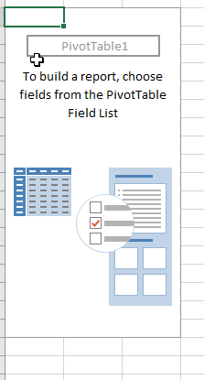

2.4 Click on Value Field Settings in **Count of Net Sales**

2.5 Choose **Sum** and click **OK**

2.6 The output of the new sheet looks like the following

2.7 Change the formatting to **Currency**

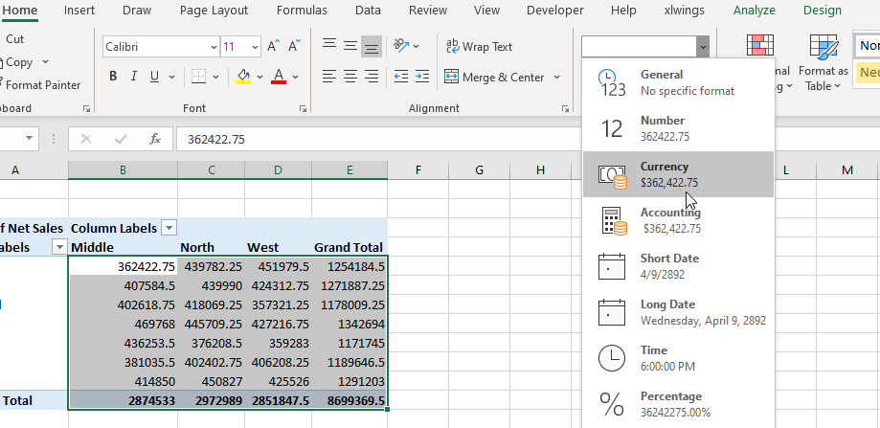

2.8 The final sheet looks like the following:

